GALAPAGOS ONBOARD A CRUISE

5 DAYS / 4 NIGHTS YACHT BONITA

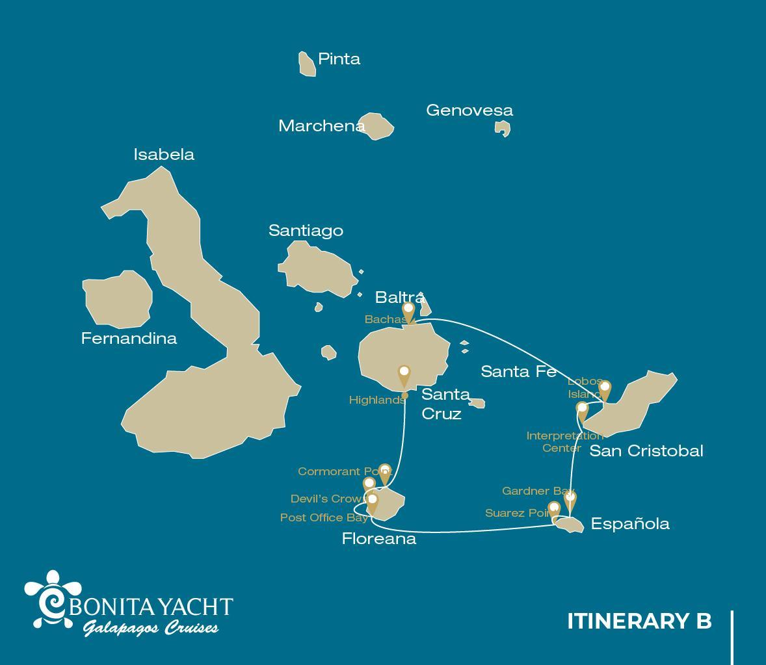

 |  |  |  | HIKING | SNORKEL | PANGA RIDE | PADDLE BOARD | KAYAK
5 DAYS CRUISE "B" | SATURDAY | PM | Santa Cruz: Highlands | •
 | SUNDAY | AM | Floreana: Cormorant Point / Devil's Crown | • | • | •
 |  | PM | Floreana: Post Office Bay | • | •
 | MONDAY | AM | Española: Suarez Point | •
 |  | PM | Española: Gardner Bay /Osborn Islet | • | • | • | • | •
 | TUESDAY | AM | San Cristobal: Interpretation Center/kicker Rock | • | •
 |  | PM | Lobos Island: Lobos Island | • | • | •
 | WEDNESDAY | AM | Santa Cruz: Bachas | • | •

DAY 1
AM: BALTRA AIRPORT
Departure to the Galapagos Islands, arrival at Baltra airport, where our naturalist guide of the National Park will be waiting for you.
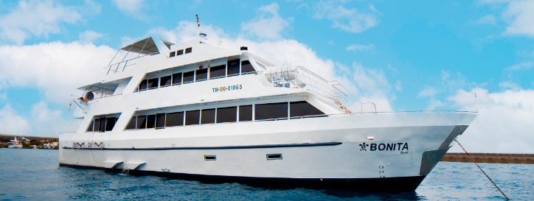
PM: HIGHLANDS
Either if you do this visit starting from Baltra or from Puerto Ayora, a bus will take you to the highlands stopping along the way at one of the reserves to visit the lush highland forests where you will look for Galapagos Giant tortoises in their natural environment. This is the best place in the Galapagos to see these gentle giants (reaching over 300 kg / 600 pounds!) casually grazing and resting in freshwater ponds. This is also home for a great diversity of birds rarely found at the lowlands, including finches (tree, woodpecker and vegetarian finches), flycatchers and several species of water birds. You will visit a lava tunnel (depending on the itinerary) and learn how these extraordinary formations were created by ancient volcanic eruptions.
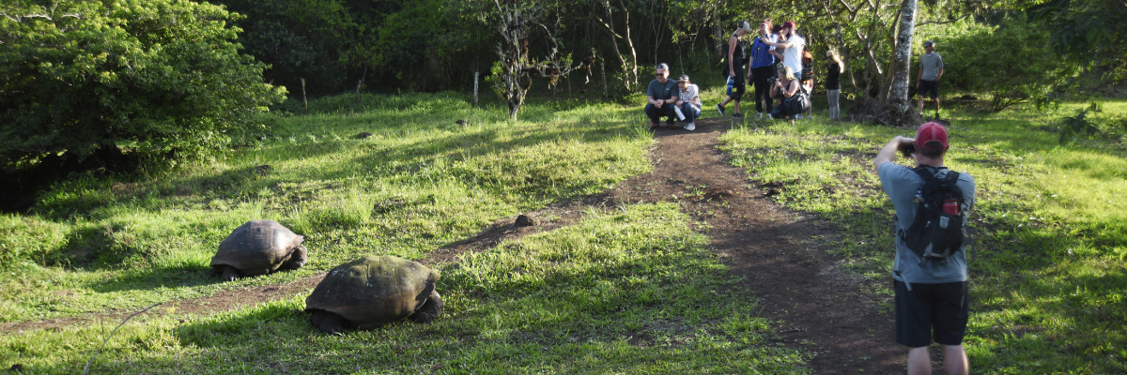
Highlights: Giant tortoises, Darwin finches, barn owls, white-cheeked pintails, Galapagos flycatchers, Lava tunnels.
Meals | L/D
Trail | 1 - 1,5 km / 0,6 – 0,9 mi
Level | 1
Activities | Dry landing and hiking

DAY 2
AM: CORMORANT POINT / DEVIL'S CROWN

Punta Cormorant is located in the north of Floreana and it is known for its large coastal lagoon with American flamingos, white-cheeked pintails, black-necked stilts and other shorebirds. There is a beautiful white sand beach which is an important nesting ground for green sea turtles where we can also see rays and reef sharks. In recent years, a small group of blue footed boobies have started to breed right by the trail. This is also a great trail dayto look at endemic plants.
Snorkel: It will be done at Devil’s Crown, a heavily eroded little volcano right by Floreana island. This is considered by many as one of the best snorkeling sites in the entire archipelago as the current funnels plankton through the Crown, attracting huge schools of snapper, Creole fish parrot fish, angelfish, reef sharks, sea turtles, rays and a phenomenal amount of marine life.
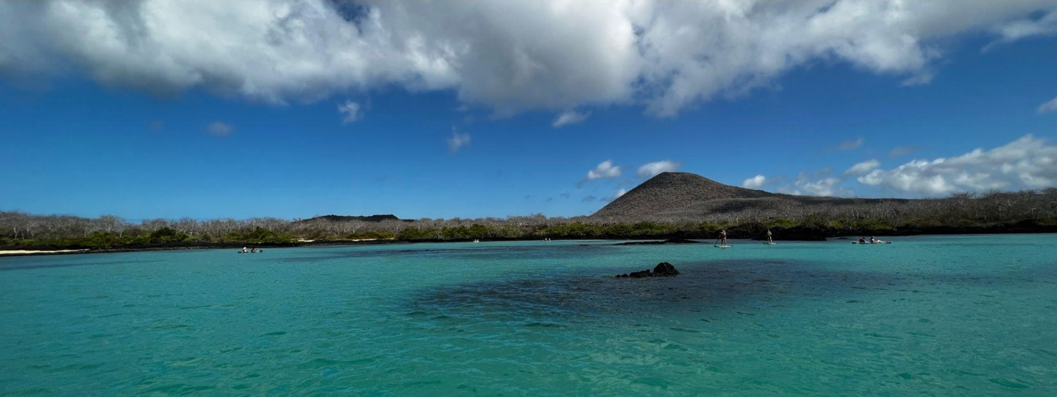
Highlights: American flamingo, blue-footed booby, frigatebirds, tropicbirds, Galapagos shearwaters, sea lions, sea turtle nesting site, finches, shorebirds, coral-sand beach.

Trail | 1,6 km / 1 mi
Level | 1
Activities | Wet landing and hiking

PM: POST OFFICE BAY
Floreana is famous for the tales of German settlers and the baroness during the late 1920’s and 30‘s. Assassinations, disappearances and other unsolved mysteries are the ingredients of this fascinating story.
Post office bay was often used by whalers to anchor their ships and go up to the highlands to get freshwater and tortoises. Most boats visiting the Galapagos had to come to this place sooner or later, so a system of mail was established more than 200 years ago: a barrel near the beach became the way to leave messages to other ships and also to the outside world. This mail system is still in use and will allow you to send postcards from the Galapagos to the outside world. Aside from a small beautiful beach and a lava tunnel, the area is great for dinghy tours to look for sea lions, green sea turtles, shorebirds, small sharks and, with some luck, Galapagos penguins.
Snorkel: There is great snorkel from the beach, as you can see lots of sea turtles, rays, great diversity of fish and, if you are really lucky, Galapagos penguin
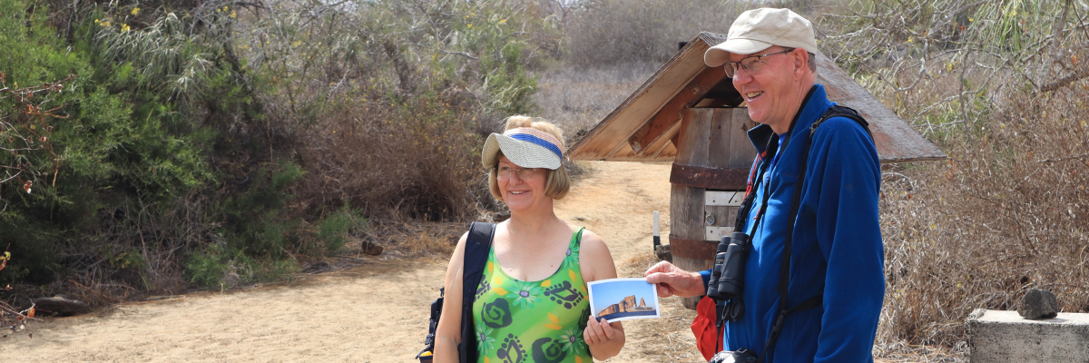
Highlights: Sea Lions, sea turtles, finches, shorebirds, marine iguanas, penguins.
Meals included | Breakfast, Lunch, and Dinner
Trail | 0,7 km / 0,4 mi
Level | 1
Activities | Wet landing and hiking

DAY 3
The Suarez Point itinerary has been changed since September 20, 2023, due to a contingency conservation plan for the species on this island. By the authorization of the Galapagos National Park, only a 360-degree panga tour around the island will be allowed.
This itinerary will return to normal once the Galapagos National Park deems it optimal for welcoming guests again.
AM: SUAREZ POINT
This rocky trail is one the most amazing nature walks you can do in the Galapagos islands.
From the moment you set foot on the island and all the way along the trail the amount and diversity of fauna is truly amazing. Sea lions and marine iguanas will be the first ones welcoming us, followed by large colonies of sea birds, including Nazca and Blue-footed boobies, gulls and tropicbirds. At the end of the trail we will visit a colony of waved albatross (April to January), the largest bird in the islands and one of the most interesting because of its powerful flight and elaborate courtship. Waved albatross only nest at Española, so this is the only place where you will see them at close range.
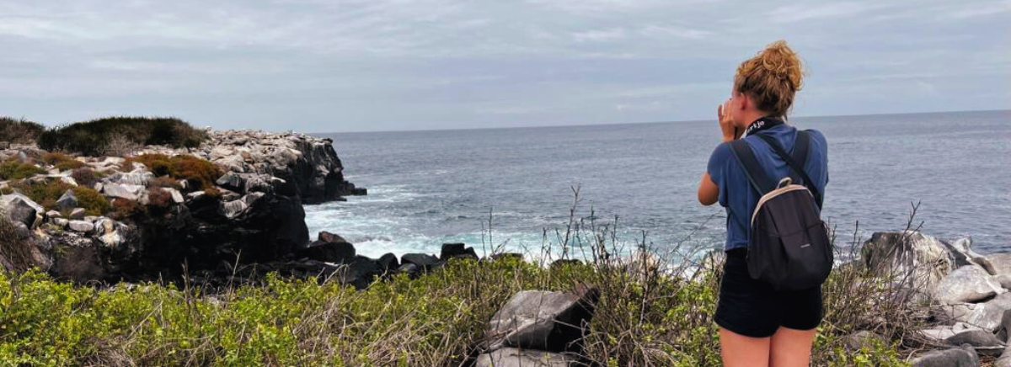
Highlights: Sea lions, Waved Albatross, Galapagos hawks, Española mockingbirds, Darwin finches, marine iguanas, Nazca & Blue-footed Boobies, Red-billed Tropicbirds, Swallow-tailed gulls, herons, lava lizards, herons.
Trail | 1,7 km / 1,1 mi
Level | 3
Activities | Panga ride only

AM: GARDNER BAY
Gardner beach is undoubtedly one of the most beautiful and interesting beaches to visit in the Galapagos. It's fine coral sand and turquoise water give it a totally tropical appearance, which contrasts with the presence of sea lions basking in the beach. You will have the opportunity to walk along the beach and learn about the biology of sea lions and other endemic species, such as the Española mockingbird, marine iguanas and Galapagos hawks.
Snorkel: There are several great snorkeling places at Gardner bay. It is a fantastic site to swim with sea lions, reef sharks, rays and many species of fish, including; Angelfish, Parrotfish, Damselfish, Surgeonfish and many others.
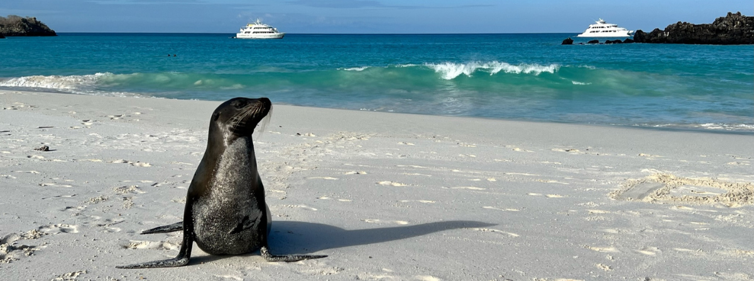
Highlights: Coral sand beach, sea lions, Galapagos hawks, Española mockingbirds, Darwin finches, marine iguanas.
Meal | B/L/D
Trail | 0,8 km / 0,5 mi
Level | 1
Activities | Wet landing and hiking

DAY 4
AM: INTERPRETATION CENTER / KICKER ROCK
Located in the outskirts of Puerto Baquerizo, this center is dedicated to the history of human presence in the Galapagos. Since the times of the early Spanish explorers to the present times, including illustrious visitors such as Charles Darwin, this permanent exhibition will take you through the dangers and struggles of the first settlers trying to survive the harsh Galapagos environment.
Snorkel: Depending on the itinerary, snorkel is allowed around Kicker Rick. Very good place to see sharks, sea turtles, rays and a lot of different species of fish. Great diversity of invertebrates growing in the vertical walls.

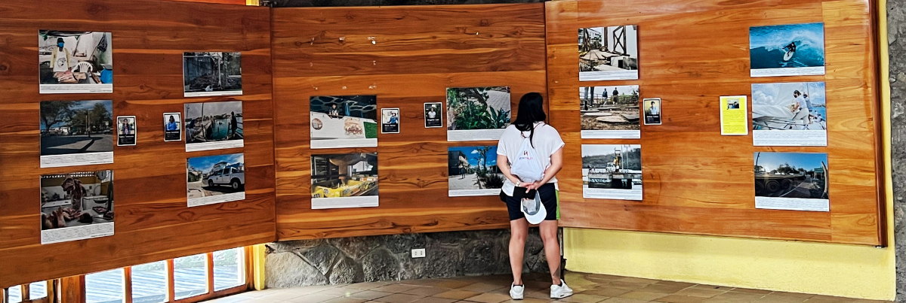
Highlights: Endemic plants, exhibition on human history
Trail | 0,2 km / 650 ft
Activities | Dry landing and hiking

Rising up vertically to more than 460 ft. high, Kicker Rock is an imposing volcanic formation a couple of miles off the coast of San Cristobal. Its vertical cliffs are a breeding ground to boobies and tropicbirds, while the slopes in the northern side host breeding colonies of frigatebirds. No landing allowed but a circumnavigation will give spectacular views of the rock while you look for birds from the sundeck.

PM: LOBOS ISLAND
Lobos island is a small islet separated from San Cristobal by a narrow channel, forming a sheltered bay where sea lion pups play in tidal pools. Despite its small size, the island is surprisingly packed with wildlife, especially with “lobos marinos”, the Spanish name for sea lions. Groups of sea lions will welcome you at the landing spot, but as you walk a few steps inland, male frigatebirds displaying their inflated red balloons will be perched on the bushes and trees. A small colony of blue footed boobies, which often nest right on the trail, will give you the opportunity to observe their famous courtship dance.
Snorkel: This is a great snorkeling location as the water are usually calm and the sea lions often play with divers to show off their swimming skills. Sea turtles and rays are often seen resting in the sandy bottoms.
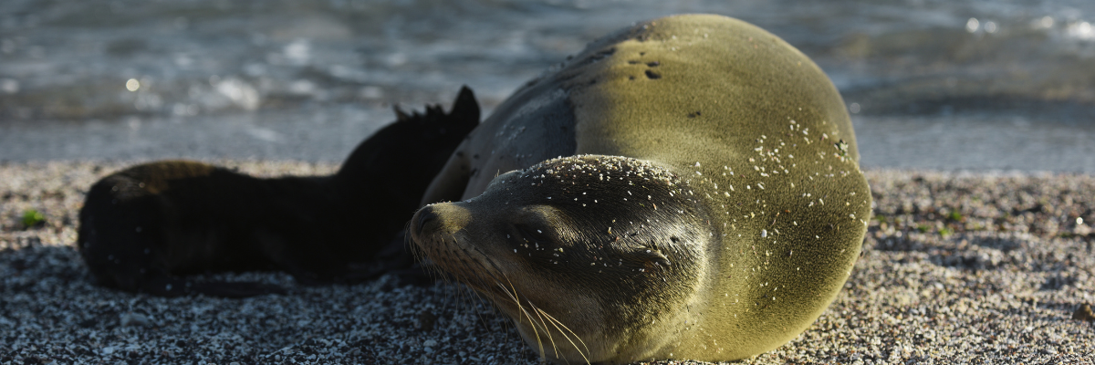
Highlights: Galapagos sea lions, marine Iguanas, magnificent & great frigatebirds, blue-footed Boobies, San Cristobal Lava Lizards.
Meals | B / L / D
Trail | 0,6 km / 0,4 mi
Level | 3
Activities | Dry landing and hiking

DAY 5
AM: BACHAS
Bachas gets its name from the remains of two large barges (mispronounced by locals as “bachas”)
left by the Americans during WWII. At low tide you can still see the iron skeletons of the barges
buried in the white sand. From November till May, this place is also one of the most important sea turtle nesting grounds in the entire Galapagos islands. There are also several small saltwater, lagoons where we often see flamingoes, herons, and other aquatic birds.
Highlights: American flamingoes, white cheeked pintails, sandpipers, lava gulls, blue footed boobies.
Meals | B
Trail | 1,6 km / 1 mi  Then, transfer to the airport to take your flight back to continental Ecuador.
Level | 1
Activities | Wet landing and hiking

Glossary

Meals | Breakfast | B
 | Lunch | L
 | Dinner | D
Hiking Effort | Level 1 | Easy
 | Level 2 | Moderate
 | Level 3 | Hard

